**PART A**

1. Menghitung Luas Segitiga

Source code

|  |
| --- |
| public class luasSegitiga {  public static void main(String[] args) {  // input  float alas = 20;  float tinggi = 25;   // luas segitiga  float luas;  luas = 0.5f * alas * tinggi;  System.*out*.println("Luas Segitiga: " + luas);  } } |

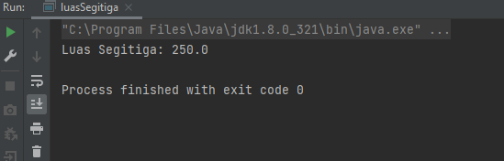

1. Konversi Nilai

Source code

|  |
| --- |
| public class konversiNilai {  public static void main(String[] args) {  // input  int studentScore = 80;   // proses konversi   if(studentScore <= 100 && studentScore >= 80){  System.*out*.println("Nilai Mahasiswa: A");  } else if ( studentScore <= 79 && studentScore >= 65){  System.*out*.println("Nilai Mahasiswa: B+");  } else if ( studentScore <= 64 && studentScore >= 50){  System.*out*.println("Nilai Mahasiswa: B");  } else if ( studentScore <= 49 && studentScore >= 35){  System.*out*.println("Nilai Mahasiswa: C");  } else if ( studentScore <= 34 && studentScore >= 0){  System.*out*.println("Nilai Mahasiswa: D");  } else {  System.*out*.println("Nilai Mahasiswa: invalid");  }   } } |

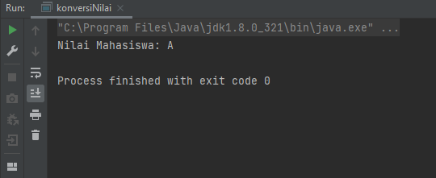

1. Faktor Bilangan

Source code

|  |
| --- |
| public class faktorBilangan {  public static void main(String[] args) {  int bilangan;   //proses  bilangan = 20;  int s;  for (int i = 1; i <= bilangan; i++){  s = bilangan % i;  if (s == 0){  System.*out*.println(i);  }  }  } } |

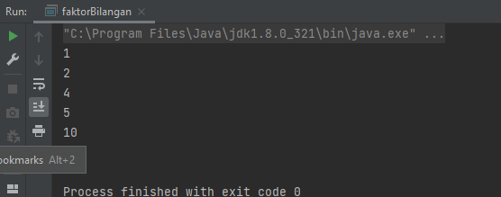

1. Faktor Bilangan II

Source code

|  |
| --- |
| public class faktorBilangan2 {  public static void main(String[] args) {  int bilangan;   //proses  bilangan = 20;  int s;  for (int i = bilangan; i >= 1; i--){  s = bilangan % i;  if (s == 0){  System.*out*.println(i);  }  }  } } |

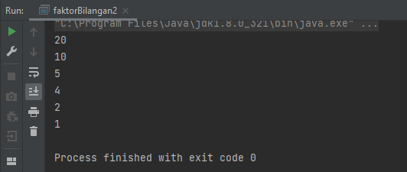

1. Bilangan Prima

Source code

|  |
| --- |
| public class bilanganPrima {   static boolean primeNumber(int number){  boolean hasil;  hasil = true;  int x = 0;  for (int i = 1; i <= number; i++){  if (number % i == 0){  x++;  }  }  if (x==2){  hasil = true;  }else {  hasil = false;  }  return hasil;  }   public static void main(String[] args) {  System.*out*.println(*primeNumber*(11)); //true  System.*out*.println(*primeNumber*(13)); //true  System.*out*.println(*primeNumber*(17)); //true  System.*out*.println(*primeNumber*(20)); //true  System.*out*.println(*primeNumber*(35)); //true  } } |

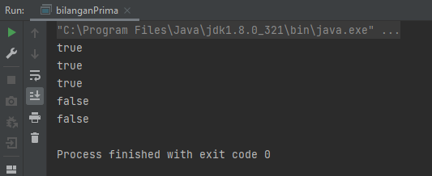

1. Palingdrome

Source code

|  |
| --- |
| public class palingdrom {  private static boolean palingdrome(String value){  boolean cek = true;  String teksKebalikan = "";  int jmlh = value.length();  for (int i = jmlh - 1; i >= 0; i--){  teksKebalikan += value.charAt(i);  }  if (value.equalsIgnoreCase(teksKebalikan)){  cek = true;  }else {  cek = false;  }  return cek;  }   public static void main(String[] args) {  System.*out*.println(*palingdrome*("civic"));  System.*out*.println(*palingdrome*("katak"));  System.*out*.println(*palingdrome*("kasur rusak"));  System.*out*.println(*palingdrome*("kupu-kupu"));  System.*out*.println(*palingdrome*("lion"));  } } |

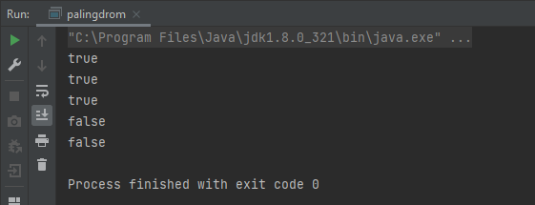

**PART B**

1. Exponentiation

Source code

|  |
| --- |
| public class exponentiation {   private static int pangkat(int a, int b){  int hasil = 1;  for(int i = 1; i <= b; i++){  hasil = hasil * a;  }  return hasil;  }   public static void main(String[] args) {  System.*out*.println(*pangkat*(2, 3)); //8  System.*out*.println(*pangkat*(5, 3)); //125  System.*out*.println(*pangkat*(10, 2)); //100  System.*out*.println(*pangkat*(2, 5)); //32  System.*out*.println(*pangkat*(7, 3)); //343  } } |

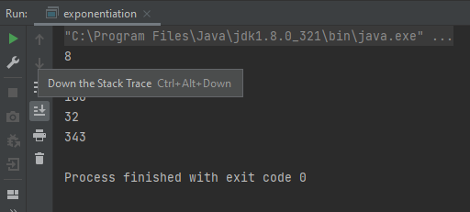

1. Play With Arterisk

Source code

|  |
| --- |
| public class playWithAsterisk {   private static void bintang(int n){  int space = n-1;  for (int x = 1; x <= n; x++){  for (int y = space; y >=1; y--){  System.*out*.print(" ");  }  for (int z = 1; z <=x; z++){  System.*out*.print("* ");  }  System.*out*.println(" ");  space--;  }  }   public static void main(String[] args) {  *bintang*(5);  } } |

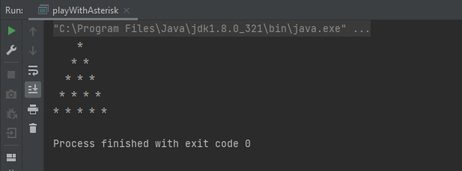

1. Draw XYZ

Source code

|  |
| --- |
| public class xyz {   private static void DrawXYZ(int n){  int index = 0;  for (int x = 1; x <= n; x++){  for (int y = 1; y <= n; y++){  index = index + 1;  if(index % 2 != 0)  {  if (index % 3 == 0){  System.*out*.print("X ");  }else {  System.*out*.print("Y ");  }  }else {  if (index % 3 == 0){  System.*out*.print("X ");  }else {  System.*out*.print("Z ");  }  }   }  System.*out*.println(" ");  }  }   public static void main(String[] args) {  *DrawXYZ*(5);  } } |

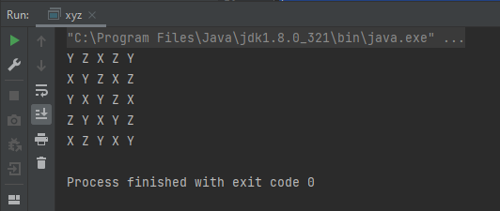

1. Cetak Tabel Perkalian

Source code

|  |
| --- |
| public class cetakTabelPerkalian {   private static void tabelPerkalian(int n){  for (int x = 1; x <= n; x++){  System.*out*.print(x);  for (int y = 2; y <= n; y++){  System.*out*.print(" " + y * x );  }  System.*out*.println("");  }  }   public static void main(String[] args) {  *tabelPerkalian*(9);  } } |

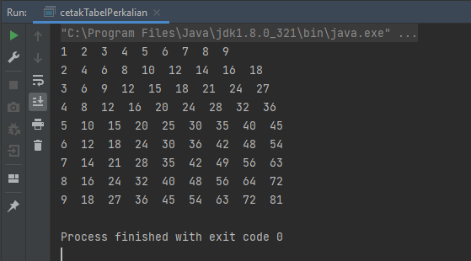

1. Ubah Huruf

Source code

|  |
| --- |
| public class ubahHuruf {  private static String ubahHuruf(String s){  char[] alphabet = {'A','B','C','D','E','F','G','H','I','J','K','L','M','N','O','P','Q','R','S','T','U','V','W','X','Y','Z'};  char[] alphabetBob = new char[26];  String huruf = "";  for (int i = 0; i < alphabet.length; i++){  int sub = 0;  sub = i + 10;  if (sub > 25){  sub = sub - 26;  alphabetBob[i] = alphabet[sub];  }else {  alphabetBob[i] = alphabet[sub];  }  }  for (int x = 0; x < s.length(); x++){  for (int y = 0; y < alphabet.length; y++){  if (s.charAt(x) == alphabet[y]){  huruf = huruf + alphabetBob[y];  }  }  }  return huruf;  }   public static void main(String[] args) {  System.*out*.println(*ubahHuruf*("SEPULSA OKE")); //COZEVCK YUO  System.*out*.println(*ubahHuruf*("ALTERRA ACADEMY")); //KVDOBBK KMKNOWI  System.*out*.println(*ubahHuruf*("INDONESIA")); //SXNYXOCSK  System.*out*.println(*ubahHuruf*("GOLANG")); //QYVKXQ  System.*out*.println(*ubahHuruf*("PROGRAMMER")); //ZBYQBKQQOB  } } |

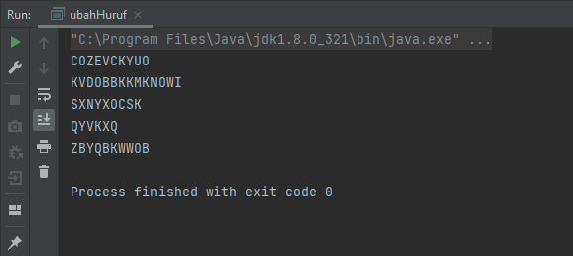

1. Mean

Source code

|  |
| --- |
| public class mean {  private static float Mean(float[] numbers){  float tambah = 0;  for (int i = 0; i < numbers.length; i++){  tambah = tambah + numbers[i];  }  return tambah / numbers.length;  }   public static void main(String[] args) {  float[] value = {1,2,3,4};  System.*out*.println(*Mean*(value)); // 2.5  } } |

